**UNIT- II: The Linux File System, File and Directory management**

**Assignment 2.1**

Write a Linux command to perform the following task.

1. Create a directory <YourRollNo>. Make <YourRollNo> as the current working directory. Create the directory structure as shown below with a single command.

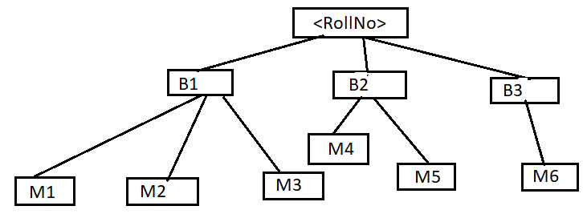

# create rollNumDir and create the directory structure given in the diagram

mkdir -p mca_18 && cd mca_18 || exit

mkdir -p b1/m1 b1/m2 b1/m3

mkdir -p b2/m4 b2/m5

mkdir -p b3/m6

Now, make M6 your current working directory and solve the following questions

1. List the files in directory B1 without actually moving to the directory.

ls ../../b1

1. Delete the directory M1.

rm -rf ../../b1/m1

Now, make <YourRollNO> as your current working directory

cd mca_18

1. Display the entire hierarchy of your directories inside <YourRollNo>.

tree

1. Write a command to list the files in directory M1, where the filename starts with a digit.

# assuming current directory is mca_18

# subshell to change to m1 directory and list

(

cd b1/m1 || exit

ls [0-9]*

)

1. Write a command to move the files from directory M1 to M3 where the file name starts with the alphabet.

mv b1/m1/[a-zA-Z]* b1/m3/

1. List all the files present in M3 which are ending with “s”

ls b1/m3/*s

1. Move the files ending with the alphabet ‘a’ in your current working directory to subdirectory B3

mv ./*a b3/

1. Write a command to list the files in your current working directory where the file name satisfies the given condition.
2. file name starts with a vowel.

ls [aeiou]*

1. The file name does not start with a vowel.

ls [!aeiou]*

1. Only five characters in the file name.

find . -maxdepth 1 -name "?????"

1. Name which contains 5 characters, out of which, first and last should be either a or b.

find . -maxdepth 1 -name "[ab]???[ab]"

1. File where name contains 3rd letter as a digit.

find . -maxdepth 1 -name "??[0-9]?*"

1. The name with the first character should not be a, b or c.

ls [!abc]*

1. Names containing "seq" in the filename.

ls ./*seq*

1. The first three characters are only digits.

find . -maxdepth 1 -name "[0-9][0-9][0-9]?*"

1. Name that starts and ends with “a”.

ls a*a

1. Name with at least 2 characters in it.

find . -maxdepth 1 -name "??*"

1. Name with exactly 2 characters in it.

find . -maxdepth 1 -name "??"

1. Delete all the directory structures that you have created so far.

​

# Asuming we are in the directory mca_18

# change back a dir

cd ..

# recursively destroy the directory structure

rm -rf mca_18